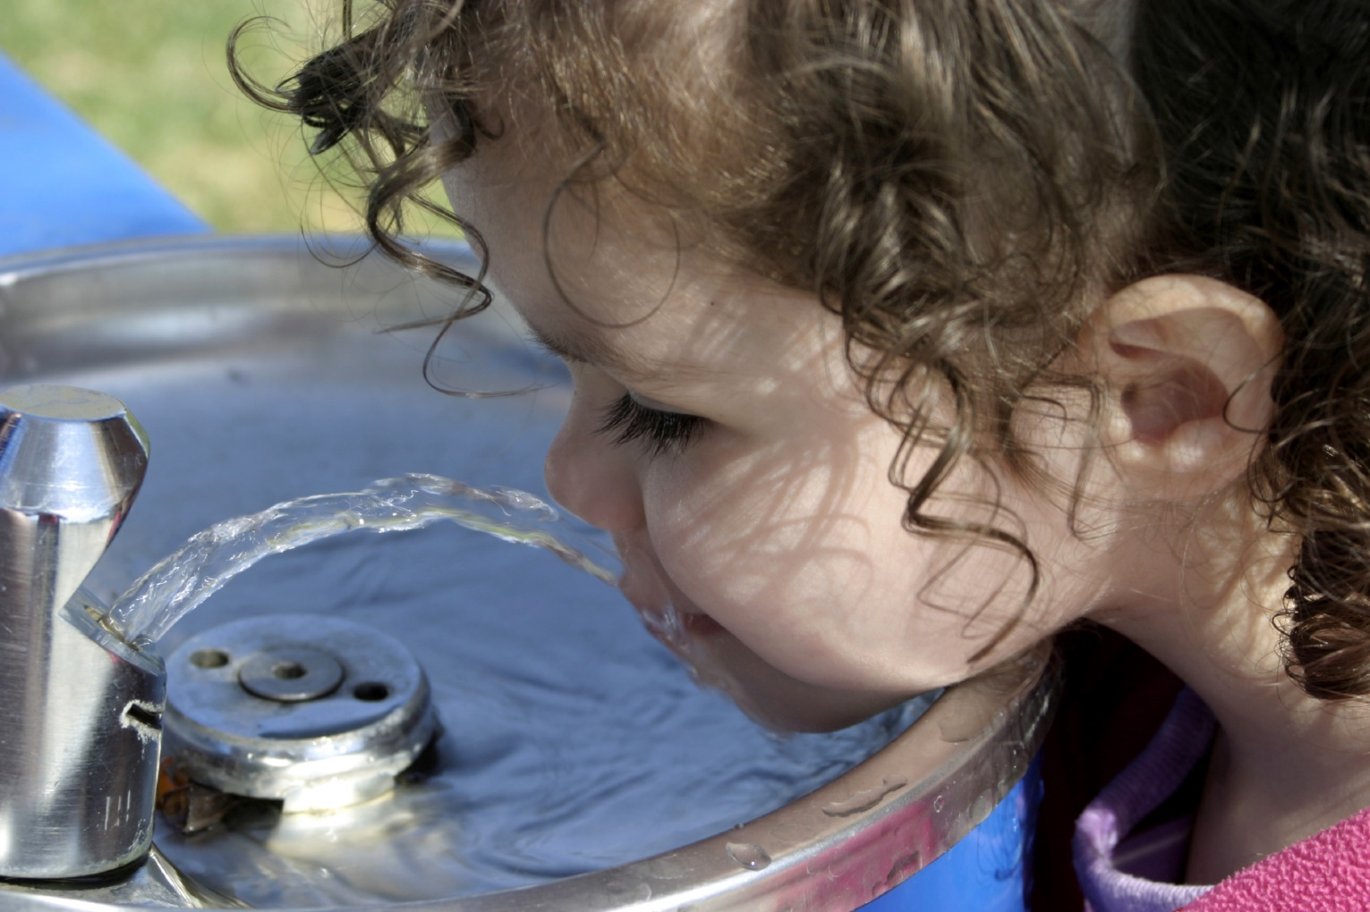
Created by the Minnesota Department of Health Climate & Health Program
in collaboration with Saint Paul – Ramsey County Public Health| November 2019
An Assessment of Heat Vulnerability
in Ramsey County

Introduction
Extreme heat events in Ramsey County and Minnesota are already occurring and are expected to become more common, more severe, and longer-lasting as our climate changes. Extreme heat events cause a significant amount of illness and death across the nation and our state. Between 1999 and 2010, more than 7,100 people died from heat-related illness in the U.S.¹ In fact, extreme heat events currently cause more deaths than any other natural disaster in the U.S.¹ The good news is that heat-related health impacts are entirely preventable by taking appropriate environmental and community measures to ensure that people can stay cool and hydrated during an extreme heat event.
To support Minnesota communities preparing for and protecting public health from extreme heat events, the Minnesota Department of Health and the University of Minnesota U-Spatial collaborated to develop the Heat Vulnerability in Minnesota mapping tool (https://maps.umn.edu/climatehealthtool/heat_app/). The tool organizes data specific to heat sensitivity and exposure in Minnesota to help local public health, emergency management, and planning professionals identify population/community-level vulnerabilities, streamline heat adaptation efforts, and tailor local heat response solutions to increase community resilience.
One way to better plan for extreme heat events is by developing a community heat vulnerability assessment. This heat vulnerability assessment for Ramsey County serves as an example of how to utilize data from the tool to begin to understand the people and places that are more susceptible to negative health impacts of extreme heat. For this assessment, vulnerability is framed as a function of sensitivity and exposure. As defined in Figure 1, exposure, sensitivity, potential impact, and adaptive capacity collectively inform heat-related health vulnerability.
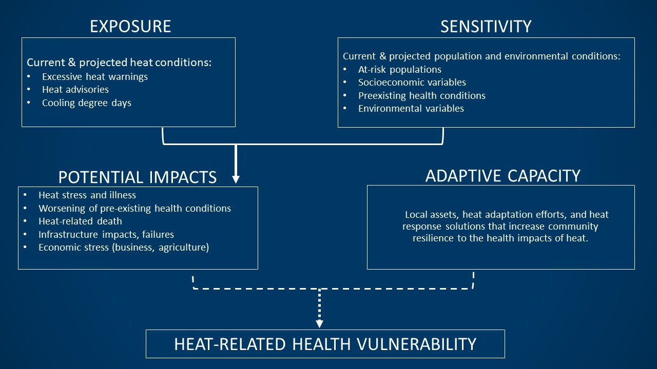
Figure 1: Heat-Related Health Vulnerability Diagram, adapted from “Assessing Health Vulnerability to Climate Change: A Guide for Health Departments,” Centers for Disease Control and Prevention, 2017. (www.cdc.gov/climateandhealth/pubs/AssessingHealthVulnerabilitytoClimateChange.pdf)

Why is extreme heat a concern for Ramsey County?
Climate change is a global phenomenon that creates local impacts. Extreme heat events that once were considered rare and record-breaking in our region are expected to become much more commonplace. Extreme heat events are characterized by weather that is substantially hotter and/or more humid than average for a particular location at a particular time, especially in the spring and summer. Criteria for defining an extreme heat event differ by place and timing, given that the experience of heat is dependent on the level of acclimatization in the population. For example, April temperatures considered commonplace in Phoenix, Arizona may seem extreme to people living in Minnesota. In general, extreme heat events refer to an extended period of time with unusually hot weather conditions for that particular place and time of year.
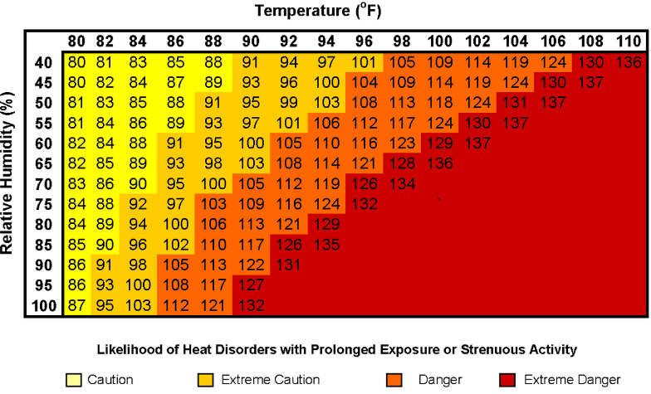
Many weather stations use the Heat Index to communicate heat risk. The HI is a measure of how hot it really feels when relative humidity is factored in with the actual air temperature. For example, 90°F air temperature feels like 109°F when the relative humidity is 75%. When a person is exposed to high heat and humidity, their body has a harder time maintaining its normal temperature of 98.6°F. Illness or death may result if the core temperature of the body increases and cannot cool down.
The National Weather Service (NWS) declares an excessive heat advisory or warning depending on the location of the station issuing the alert and the weather in its own service area.
Figure 2: National Oceanic and Atmospheric Administration’s (NOAA) National Weather Service Heat Index
National Weather Service (NWS) Heat Warnings and Advisories | Ramsey County
NWS Excessive Heat Warnings (2009-2018)  Excessive heat warnings are issued within 12 hours of the onset of an extremely dangerous heat event. Generally, a warning is issued when the maximum heat index is expected to be 105°F or higher for at least 2 days and nighttime air temperatures will not drop below 75°F. These criteria will vary, especially for areas not used to extreme heat conditions. It’s advised to take precautions immediately when conditions are extreme to prevent illness or death.² | 14
NWS Excessive Heat Advisories (2009-2018)  Heat advisories are issued within 12 hours of the onset of an extreme heat event. In general, an advisory is issued when the maximum heat index is expected to be 100°F or higher for at least 2 days, and nighttime air temperatures are not expected to drop below 75°F. It’s advised to take precautions to avoid heat illness to prevent illness or death.² | 32

Extreme Heat Impacts Health in Ramsey County
Extreme heat impacts health in Ramsey County by causing heat-related illnesses and making some existing illnesses and health conditions worse. Symptoms of heat-related illnesses can include heat rash, swelling in the extremities (edema), breathing difficulties, muscle cramps, dizziness or fainting, profuse sweating, weakness, nausea or vomiting, dehydration, headache, confusion, loss of consciousness, and even death.

Ramsey County experienced
352 emergency department visits from 2011-2015
and 75 hospitalizations from 2006-2015
due to extreme heat.

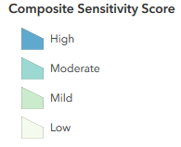  Heat-related emergency department visits in MN, by county (2011-2015) | Heat-related hospitalizations in MN, by county (2006-2015)
How to Interpret the Vulnerability Maps
Relative vulnerability is shown by calculating a composite score of selected variables for each geographic area. The range of values for each variable is divided into quartiles (1-lowest to 4-highest) and then the quartiles are summed across the variables. For example, if 3 variables are selected a score of 12 means the geographic area is at the highest ranking for each variable (3 variables x 4 (highest score for each variable) = 12), suggesting an increased risk for health impacts related to heat compared to other geographic areas in the state. These quartiles are illustrated on the maps in this report through a Composite Score, showing the 1-low, 2-mild, 3-moderate, and 4-high. More information about how the tool works is available in the user guide linked on the tool website (https://maps.umn.edu/climatehealthtool/heat_app/).

Exposure to Extreme Heat in Ramsey County is Changing
Climate change is affecting seasonal temperatures in Minnesota. If no action is taken to reduce heat-trapping emissions, the number of days in Minnesota with a heat index above 90°F could quadruple by around 2050.³ Furthermore, daily minimum temperatures or overnight lows are increasing faster than daytime high temperatures, which limit the ability to cool off at night.
To understand how climate change may impact factors like temperature and how much we need to adapt to protect health, scientists use Representation Concentration Pathways (RCP) to make predictions about how greenhouse gas concentrations will change over time as a result of human activities. The tool and this assessment highlight two RCP future scenarios:

Under RCP 4.5 and 8.5 future climate scenarios, it’s anticipated that
Ramsey County will experience a
20% and 59% increase in cooling degree
days respectively by 2050.

- RCP 4.5: Human efforts to curb emissions is medium, leading to moderate increases in extreme weather and requiring medium efforts to adapt. Under this future scenario, emissions peak around mid-century and then decline rapidly over 30 years before stabilizing.
- RCP 8.5: Human efforts to curb emissions is low, leading to large increases in extreme weather and requiring significant efforts to adapt. This future scenario shows emissions continuing to increase rapidly through the early and mid-parts of the century.

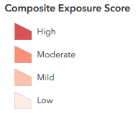
Cooling Degree Days (2019)
Cooling degree days, which are often used as a proxy to estimate cooling needs for buildings, can be examined as a baseline and projected exposure indicator under the RCP 4.5 and RCP 8.5 scenarios. Cooling degree days are indexed units, not actual days, which roughly describe the demand to heat or cool a building. Cooling degree days accumulate on days warmer than 65°F when cooling is required. For example, if a weather station recorded an average daily temperature of 78°F, cooling degree days for that station would be 13. The 2019 Cooling Degree Days map illustrates modeled data for the composite exposure by county, where Ramsey County ranks moderate compared to other counties in Minnesota.

Who’s Most At-Risk?
Although everyone can be affected by the heat, some people are at greater risk of heat-related illnesses than others. Some risk factors can lead to increased exposure to heat, while other factors may affect people’s ability to regulate their body temperature.
The following table explains some factors that can increase vulnerability to heat-related health impacts. A series of maps follows to demonstrate the spatial distributions of notable factors in Ramsey County.
Factors that can increase vulnerability to heat-related health impacts
Demographic characteristics
- Children under 5: Children, especially children ages five years and younger can be at greater health risk during hot weather. Children may be at increased risk due to a range of factors, including: dependency on other people for care; physiological differences, including smaller body mass to surface area ratio compared to adults; blunted thirst response; production of more metabolic heat per pound of body weight; and lower cardiac output.⁴
- Males age 15-34: People 15-34 years of age, especially males, are most likely to visit the emergency department for heat-related illness in Minnesota. In fact, males are about twice as likely to visit the emergency department for heat-related illness as women. The majority of public health alerts during heat waves focus on the very young and the very old since they are at higher risk for death and longer hospitalizations. However teens and younger adults, particularly those in athletics or working outdoors, also need to take steps to prevent heat-related illnesses.⁵
- Adults age 65+: Certain physiological changes associated with aging, especially the body’s decreased ability to thermoregulate, increase older adults’ risk of experiencing heat-related illnesses. Chronic disease conditions and the use of certain medications also may increase older adults’ susceptibility to adverse health outcomes from heat.⁴
- People of color and American Indians: Race may increase vulnerability to heat-related illness and mortality. Studies have shown higher rates of renal failure, hospital admissions for cardiovascular and respiratory disorders, and heat-related mortality in persons of color, particularly in the African American population. The health disparities among populations of color may be a result of a number of sources, including “cultural differences in lifestyle patterns, inherited health risks, and social inequalities that are reflected in discrepancies in access to health care, variations in health providers’ behaviors, differences in socioeconomic position, and the effects of race-based discrimination”.⁶
Socioeconomic factors
- Age 65+ living alone: Older adults who live alone are particularly vulnerable to negative health outcomes from extreme heat because of a combination of factors associated with aging, social isolation, and economic constraints. Socially isolated people may be less likely to recognize the symptoms of excessive heat exposure, less likely to leave their homes if hot, and/or less willing or able to reach out for help from others.⁴
- Persons living at or below poverty line: Economic constraints can increase the risk of heat-related illness, as people living at or below the poverty line are less likely to have air conditioning and may have difficulty paying for increased electricity usage during an extreme heat event.⁴
- Limited English: Limited English populations may be isolated from receiving health protective communication. This may possibly increase risk for heat-related illnesses due to not understanding heat warnings and/or heat-related educational messages or they may not yet be familiar with the local climate.⁷
- Less than high school diploma: Heat vulnerability assessments use this factor as a marker of adaptive capacity.⁸ Populations with less education may have less ability to cope with the impacts and aftermath of an extreme heat event.

Composite demographic characteristics at risk for heat impacts in Ramsey County,
2018 by block group
(Percent population under 5 years old, percent population males ages 15-34, percent population over 65 years old, and percent population people of color and American Indian)

Populations most at-risk for health impacts from heat in Ramsey County, 2018 by block group
Percent under 5 years old | Percent males ages 15-34
Percent over 65 | Percent people of color and American Indians

How are Ramsey County demographics changing?
Demographics, 2018 | Counts (Individual) | Percentage of Population
Total Population | 543,936 | n/a
Under age 5 | 34,830 | 6%
Male ages 15-34 | 81,520 | 15%
Age 65+ | 82,014 | 15%
People of color and American Indians** | 211,849 | 39%
*2018 demographic information in the tool and this assessment is from the ESRI U.S. Updated Demographics, which includes a large margin of error.
**Population projections were not available for People of Color and American Indians at the time of this report.
Demographic Projections, 2050 | Counts (Individual) | Growth Rate from 2018
Total Population | 688,964 | 27%
Under age 5 | 52,407 | 50%
Male ages 15-34 | 108,546 | 33%
Age 65+ | 102,555 | 25%

Composite of socioeconomic risk factors in Ramsey County, 2018 by block group
(Percent population limited English, percent population living at or below poverty line, percent with less than high school diploma, and percent over 65 and living alone.)

Individual maps of socioeconomic risk factors in Ramsey County by block group
Percent limited English | Percent Persons living at or below the poverty line
Percent less than high school diploma | Percent over 65 and living alone

What Other Factors Influence Risk?
Health and environmental variables can also influence heat-related illness. Extreme heat can be life-threatening for Medicare beneficiaries and those who rely on electricity-dependent medical equipment (i.e., ventilators) to live independently because they may have more underlying conditions. The availability and use of air conditioning as an environmental protective factor is also important to consider, but was not included in this assessment because air conditioning usage data is not publically available.
Health and environmental variables, 2019 | Percent / number of Ramsey County households, 2019
Medicare beneficiaries | 15% / 82,341
Electricity-dependent Medicare beneficiaries | <1% / 2,708

Urban Heat Island Effect
Another environmental factor to consider is the urban heat island effect. The urban heat island effect is a measurable increase in ambient urban air temperature and results primarily from the replacement of vegetated land with impervious surfaces, such as roads, buildings, and other heat-absorbing infrastructure that captures heat throughout the day and releases it at night. During the summer months in Minnesota this temperature difference can be critically important for the health of urban residents if they’re unable to get relief from the daytime heat during the night. It’s important to note that the urban heat island effect is not confined to larger cites in Minnesota, even mid- and small sized cities can experience some degree of the urban heat island effect. Impervious surface, while not a perfect measure, can provide an indication of where the urban heat island effect might be observed. The impervious surface map by block group in 2018 can help prioritize policy and implementation strategies (e.g., targeted tree planting, public safety outreach, built environment improvements) to mitigate extreme heat risks.

Impervious surface in Ramsey County, 2018 by block group

Putting it All Together
By layering all of the sensitivity risk factors mentioned in this report, Ramsey County can begin to understand its composite vulnerability within the county. This information can help determine where to prioritize interventions and also where to explore lifting up assets that can increase the community’s ability to adapt to extreme heat.

Composite of sensitivity risk factors in Ramsey County, 2018 by block group
(Percent population under 5 years old, population males ages 15-34, population over 65 years old, population people of color and American Indian, limited English, persons living at or below poverty line, less than high school diploma, over 65 and living alone, and impervious surface)
The sensitivity risk factors highlighted in this report, and in the tool, highlight just a few of the factors that can contribute to vulnerability to extreme heat. Jurisdictions are encouraged to evaluate other important local factors to help plan for extreme heat events. Some additional factors to consider in planning include people experiencing homelessness, people with preexisting health conditions that can be worsened by heat (i.e., obesity, diabetes, renal failure, heart disease and respiratory conditions), people who are involved in sports or who work in outdoor occupations (i.e., agriculture, landscaping, construction), people who are bedridden or living in nursing homes, people living in top-floor apartments, tree canopy coverage, and air conditioning availability and use.

Next Steps & Resources
The heat vulnerability indicators provide an introductory understanding of localized heat-related risk. This broad-brush assessment can help Ramsey County and jurisdictions within the county identify where the risks are relatively higher than others and begin to uncover why. This can serve as a launching point for city and county officials, local public health, emergency preparedness and management staff, and others to:
- Investigate — Take a more nuanced look at the data in the Heat Vulnerability in Minnesota mapping tool, and consider other vulnerabilities in your community that might not be mapped. What are those additional vulnerabilities? What assets are available that might counterbalance some of the vulnerabilities? Explore resources in the U.S. Climate Resilience Toolkit as a starting point (https://toolkit.climate.gov/steps-to-resilience/assess-vulnerability-risks).
- Plan — Support ongoing community engagement and development of infrastructure, emergency response, social services, and public health planning efforts; engage appropriate stakeholders in discussions and planning work. Authentic engagement is critical; check out tools and resources for community engagement at the Minnesota Department of Health webpage (www.health.state.mn.us/communities/practice/equityengage/community/resources.html).
- Prioritize — Elevate health equity in heat-response planning and service delivery. Ready to learn more about health equity in Minnesota? There are many resources available at the Minnesota Department of Health’s health equity in public health practice webpage (www.health.state.mn.us/communities/practice/equityengage/healthequity/index.html).
Additional heat and health resources are available through the Minnesota Climate & Health Program (www.health.mn.gov/heatplanning), including:
- Heat Illness Tip Sheets — Written for the general public with steps they can take to prevent heat-related illness. Available in six languages.
- Extreme Heat Toolkit — Provides information for local governments and public health professionals about preparing for and responding to extreme heat events.
- Health, Climate and Extreme Heat Training — Educational content for local governments and public health about heat and climate change in Minnesota, issues caused by extreme heat events, and strategies to prevent heat-related illnesses.
Connect with us! Still have questions about utilizing the tool and this assessment? Curious about additional resources? Have feedback you’d like to share? Connect with us by emailing the Minnesota Climate & Health Program at climatechange@state.mn.us. We’d love to hear from you!
References
- Public Health Institute/Center for Climate Change and Health (2016). Extreme Heat, Climate Change and Health. Retrieved from http://climatehealthconnect.org/wp-content/uploads/2016/09/ExtremeHeat.pdf
- National Weather Service (2019). Heat Watch vs. Warning. Retrieved from https://www.weather.gov/safety/heat-www
- Union of Concerned Scientists (2019). Midwest Region Areas to Endure About Three Months a Year when “Feels Like” Temperature Exceeds 100 Degrees. Retrieved from https://www.ucsusa.org/press/2019/midwest-region-areas-endure-about-three-months-year-when-feels-temperature-exceeds-100
- Minnesota Department of Health (2012). Minnesota Extreme Heat Toolkit. Retrieved from https://www.health.state.mn.us/communities/environment/climate/docs/mnextremeheattoolkit.pdf
- Minnesota Department of Health (2019). Heat vulnerability in Minnesota and Wisconsin. Retrieved from https://www.health.state.mn.us/communities/environment/tracking/projects/heatvulnerabilitymnwisc.html
- Minnesota Department of Health (2014). Minnesota Climate Change Vulnerability Assessment. Retrieved from https://www.health.state.mn.us/communities/environment/climate/docs/mnclimvulnreport.pdf
- Gronlund, Carina (2014). Racial and socioeconomic disparities in heat-related health effects and their mechanisms: a review. Current Epidemiology Reports. Retrieved from https://www.ncbi.nlm.nih.gov/pubmed/25512891
- Chuang, Wen-Ching and Gober, Patricia. Predicting Hospitalization for Heat-Related Illness at the Census-Tract Level: Accuracy of a Generic Heat Vulnerability Index in Phoenix, Arizona. Environmental Health Perspectives. Retrieved from https://www.ncbi.nlm.nih.gov/pmc/articles/PMC4455581/

