TOOLBOX TALKS

Stairways

Walking up and down stairs seems simple enough. In most cases, a second thought is not given to how safe our stairways are. After all, its second nature. We use steps almost every day. However, stairways can be very dangerous if not properly inspected and maintained. Regulations for stairways can be found in Subpart D of OSHA’s General Industry standard.

- Provide handrails, stairrails, and guardrail systems.
- Ensure that vertical clearance from the stair tread to any overhead obstruction is at least 6 feet 8 inches measured from the leading edge of the tread.
- Ensure that stairs have uniform riser height and tread depth.
- Stairway landing platforms must be at least the width of the stair and at least 30 inches in depth as measured in the direction of travel.
- If a door or gate opens directly onto a stairway platform, the swing of the door should not reduce the platforms usable depth.
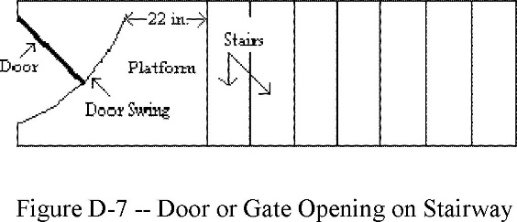
Retrieved From https://www.osha.gov/laws-regs/regulations/standardnumber/1910/1910.25
- Ensure stairways are in good repair and can support at least 5 times the anticipated load, but never less than a concentrated load of 1,000 lbs.
- Do not store materials on stairways.

